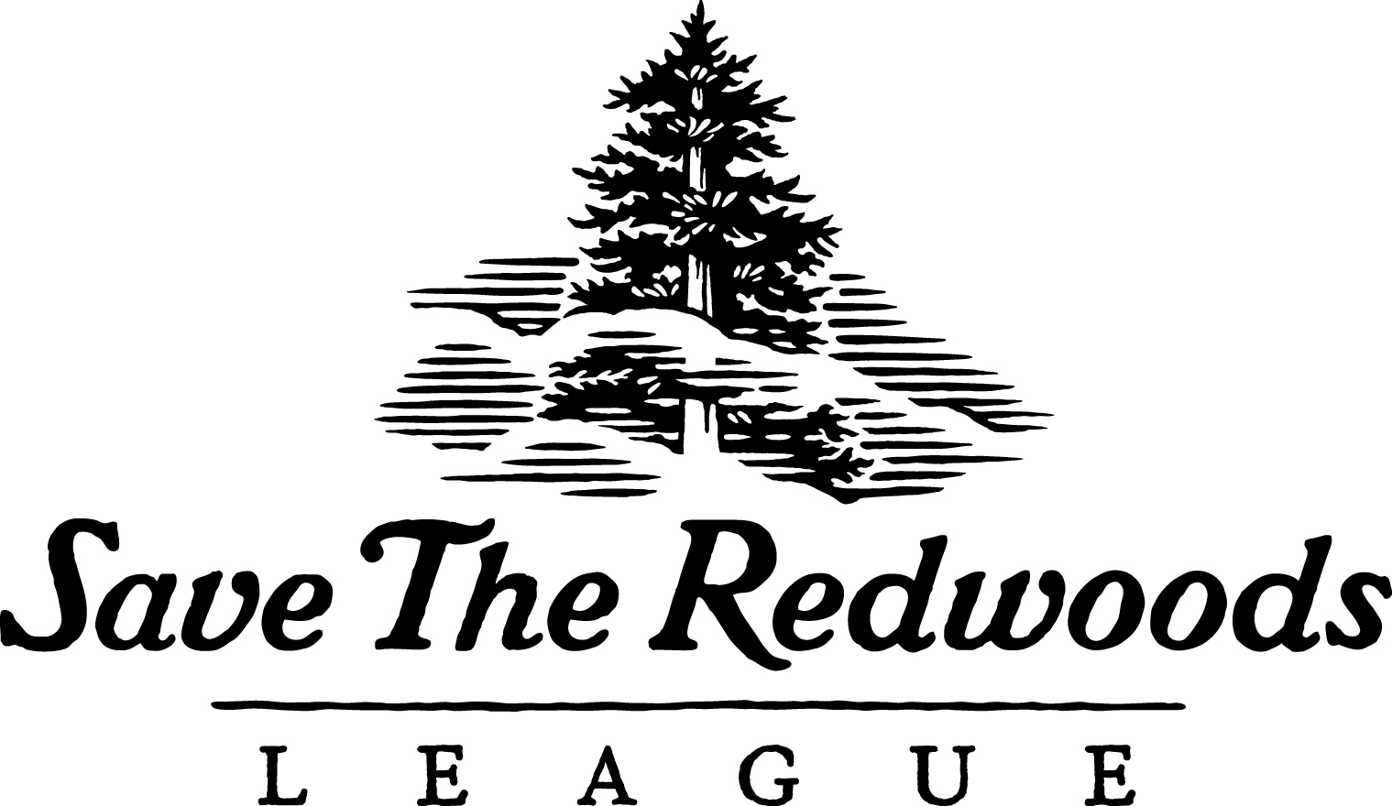

Development Services Coordinator -- Save the Redwoods League

Are you inspired by the beauty of our natural world and our majestic redwood forests? As our Development Services Coordinator, you are an essential member of the Development team, supporting the League’s direct mail and e-mail fundraising campaigns. Serving as our lead donor relations representative, you will respond to donor phone calls and e-mails, executing gift processing and acknowledgment for major donors and major donor prospects. You are also the key member to ensure our donor records are up-to-date and accurate.

We provide excellent benefits including paid vacation, sick time, medical, dental, vision, online tele-therapy, health advocacy and employee assistance programs, life insurance, and a generous 401k match!

For over 100 years, Save the Redwoods League has been dedicated to protecting the ancient redwood forests so all generations can experience the inspiration and majesty of redwoods. Since its founding in 1918, Save the Redwoods League has protected more than 200,000 acres of forests and helped create 66 redwood parks and preserves for everybody to enjoy. To learn more about us, go to www.SaveTheRedwoods.org.

RESPONSIBILITIES:

Donor Relations
- Serves as primary contact for inquiries and special requests from donors; responds in a timely manner
- Refers donors to members of the development department and other departments as appropriate
- Records all meaningful activities in data base

Gift Processing, Data Entry, and Gift Acknowledgement
- Performs daily entry and coding of gifts, pledges, and write-offs on complex and large donations received by mail
- Prepares and mails special acknowledgements for honor/memorial/tribute giving acknowledgements, etc.
- Administers Matching Gifts program; manages communications for gift verification requests; ensures accurate entry of matching gifts in database
- Manages entry of in-kind, wire transfer, and ACH gifts; manages requests for new ACH donors and processes applications; tracks donations, login information, and organizes backup
- Helps design and implements new gift entry procedures; assists in preparing documentation
- Cross-trains and provides back-up for Gift Planning Associate on stock gift and cryptocurrency gift entries
- Serves as liaison with outsourced gift processing firm
- Supports other annual giving projects

Quality Control, Monthly Reconciliation with Accounting Department
- Runs reports on all gift entry batches and methods; reviews monthly gift entry and coding
- Prepares and reviews batch reports and backs up documentation for all gifts
- Collects/saves reconciliation materials and prepares reports for monthly reconciliation for review by accounting staff; corrects errors discovered in reconciliation

Reporting, Department Support, and Other Support
- Supports the Development Department with administrative fundraising tasks and operations
- Prepares reports of front door gifts received; handles daily outgoing mail for organization
- Trains staff in gift entry and other data base functions

QUALIFICATIONS:
- Commitment to Save the Redwoods League’s mission
- Two-plus years’ nonprofit donor relations, gift processing and gift acknowledgement, customer service or similar experience
- Proficient with Microsoft Office 365, including Word and Excel, SharePoint, OneDrive, Teams, EveryAction or similar database; Asana experience a plus
- Strong donor relations/customer service orientation; proven ability to communicate effectively with donors/customers
- Strong analytical, communication and organizational skills with impeccable attention to details and able to meet deadlines
- Excellent project management skills and the ability to prioritize in a changing environment
- Self-directed with the ability to work well within a team
- Occasional weekend and evening responsibilities
- Occasionally lifts, carries, and moves objects weighing up to 30 pounds
- Occasionally required to hike through forest land and walk on uneven ground
- Demonstrated commitment to inclusion; cultural competence with the ability to communicate and interact effectively with people across cultures, ethnic groups, and identities; verbal and written fluency in a language other than English is desirable.

TO BE CONSIDERED:
Please email your resume, a cover letter addressing why you are a great fit for this role, and your salary expectations to Jobs@SaveTheRedwoods.org with "Development Services Coordinator” in the subject line.

NO CALLS PLEASE... we are busy protecting redwoods. THANK YOU!

Save the Redwoods League is an Equal Opportunity Employer and is committed to creating an
environment of equity and inclusion. Recruiting and retaining a diverse workforce is a high priority; people of all identities, backgrounds, and cultures are encouraged to apply. Learn more about our
Diversity, Equity, and Inclusion initiatives.

