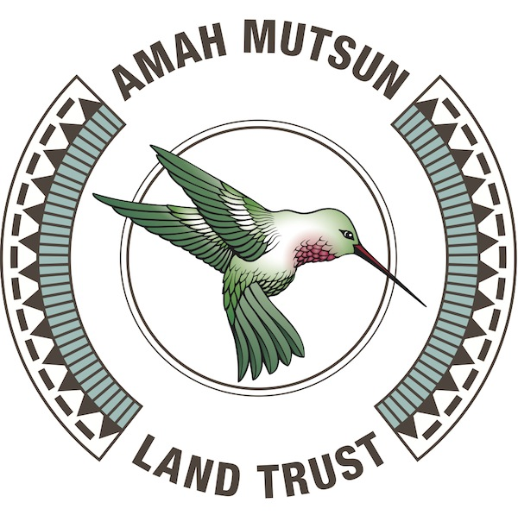
Amah Mutsun Land Trust Job Announcement:

Director of Programs

Background:
Amah Mutsun Land Trust (AMLT) is a non-profit organization founded and governed by the Amah Mutsun Tribal Band (AMTB) to promote traditional cultural and spiritual Indigenous land stewardship of Mutsun and Awaswas territories through research, conservation, restoration, and education. AMTB is comprised of the descendants of Indigenous people taken to Missions San Juan Bautista and Santa Cruz.

AMLT has developed a number of programs to fulfill its mission. These include:

- The Native Stewardship Corps, a work training, cultural education, and conservation fieldwork program for Tribe Members
- A youth stewardship camp and summer internship program for Tribal youth
- Coastal stewardship program
- Firefighting and cultural burning program
- Ethnobotanical demonstration gardens
- Research and educational programs that promote Indigenous perspectives in resource management

In addition to the major programs listed above, AMLT has several active grant-funded projects that the Director of Programs is responsible for managing, with the help of other staff and consultants. AMLT has grown rapidly over the past several years, and it is expected that the number, breadth, and depth of these programs will continue to expand.

Position Description:
The Director of Programs will be responsible for the operational success of AMLT programs, ensuring seamless program planning, execution, and completion of deliverables; team management and development; quality control; and personnel / project evaluation. Reporting to the Executive Director, the Director of Programs will assist in managing all program staff, timelines, and budgets. The Director of Programs will also play a key role in public outreach, communication with project partners, and media relations.

Director of Programs Responsibilities:
Program Planning and Administration
- With AMLT staff, maintain a management plan for all AMLT programs, including project budgets, timelines, resource needs, and deliverables
- Ensure all project goals are achieved while maintaining high professional standards of work and fulfilling all obligations to project partners
- Manage program staff and volunteers, providing strong leadership to Native Stewards, Research Associates, and Interns
- Ensure all AMLT programs have resources (e.g. staff, funding, supplies) needed to be successful
- Manage program budgets, invoicing, and payment processing
- Develop and maintain program timelines, specific project calendars / schedules, and manage specific project logistical needs
- Manage recruitment and hiring processes for new Programs staff and interns
- Develop and administer regular Programs staff evaluations
- Approve project purchases and other expenditures; collect and review receipts and other expense reimbursement requests; and organize and submit expenditures to Operations Coordinator
- Gain detailed understanding of the goals and technical requirements for each program and give direction to ensure program success
- Evaluate programs to ensure they are effective, engaging, and culturally appropriate
Business Development
- Identify and pursue new work opportunities for the AMLT Native Stewardship Corps; cultivating existing partnerships and seeking to establish new collaborations as needed
- Develop and maintain productive partnerships with conservation organizations within AMTB’s stewardship area
- Develop new programs, projects, and contracts in collaboration with AMLT staff, particularly in priority locations identified by AMTB leadership
Outreach and Education
- Ensure Tribe Member awareness of and engagement in AMLT programs and plan events to enable broader Tribal participation in AMLT’s work
- Support AMLT outreach efforts and engagement with volunteers and the public
- Represent AMLT and NSC at outreach and educational events, as well as in the media

Qualifications:
- Minimum of two years of experience successfully managing multiple, complex programs
- Excellent verbal and written communication skills with exceptional attention to detail
- Possess strong leadership qualities, time management skills, and work ethic
- Commitment to learning about and honoring Amah Mutsun culture
- Willingness to follow and enforce AMLT policies, maintain professional boundaries, and appropriately represent the organization
- Be adaptive, patient, and able to maintain a positive perspective and professional demeanor in a dynamic work environment
- Demonstrated success developing, implementing, and evaluating program models
- Proficiency in using current technology (software, platforms, and devices) to design, manage, and evaluate programs
- Ability to type at least 50 words per minute
- Ability to prioritize and respond to email and other communications promptly, efficiently, and clearly
- Demonstrated ability to take initiative to create novel solutions and to optimize existing approaches to meet and exceed project goals
- A high level of proficiency in all of the following software packages is strongly desirable:
  - Google Workspace (formerly G Suite); particularly Gmail, Drive, Calendar, Forms, Docs, and Sheets,
  - Microsoft Office Suite; particularly Excel, Word, and Powerpoint
- Proficiency with Zoom, Dropbox, digital image / video editing software, geographic information systems software, and Xero accounting software is desirable
- Strong project management skills; working with complex projects; identifying and achieving measureable goals; cultivating program growth
- Strength in hiring, recruiting, coaching, and retaining team members, empowering them to elevate their levels of responsibility and performance
- Proficient understanding of human resources, employee performance improvement and development plans, conflict resolution, and corrective action policies
Desired Knowledge, or Willingness and Aptitude to Learn:
- Contemporary challenges, concerns, and interests of Amah Mutsun Tribe Members.
- Familiarity with Amah Mutsun history, spirituality, culture, language, and Tribal identity.
- Amah Mutsun ethnobotany, spirituality, language, or traditional ecological knowledge and land stewardship practices
- Historical and contemporary impacts of colonialism on Native American peoples.

Drug and Alcohol-Free Statement
AMLT has a strict policy prohibiting the use of drugs and alcohol among staff on the job and at any AMLT work site. This includes any products containing psychoactive amounts of THC. Any violation will result in immediate termination.
Other Information
The Director of Programs will occasionally need to work up to one day per week on weekends to meet specific project needs. This position also requires willingness and ability to use a personal vehicle to travel to multiple locations in AMTB territory (from approximately Point Año Nuevo southwards to the Salinas River, eastwards to Pinnacles National Park, and northwards to Morgan Hill) on a regular basis for meetings, fieldwork planning and oversight, etc.
The initial interview for this position will be a remote interview over Zoom, which will be recorded.

Compensation: $65-80K salary, based on experience

Position Type: Full-time, exempt employee

Benefits: Medical, dental, and vision insurance and paid time off

To Apply: Please send a resume, cover letter, three references, and a writing sample (an excerpt, not to exceed one single-spaced page) to hiring@amahmutsun.org by June 4, 2021.
Contact: For more information or questions, send an email to hiring@amahmutsun.org.

