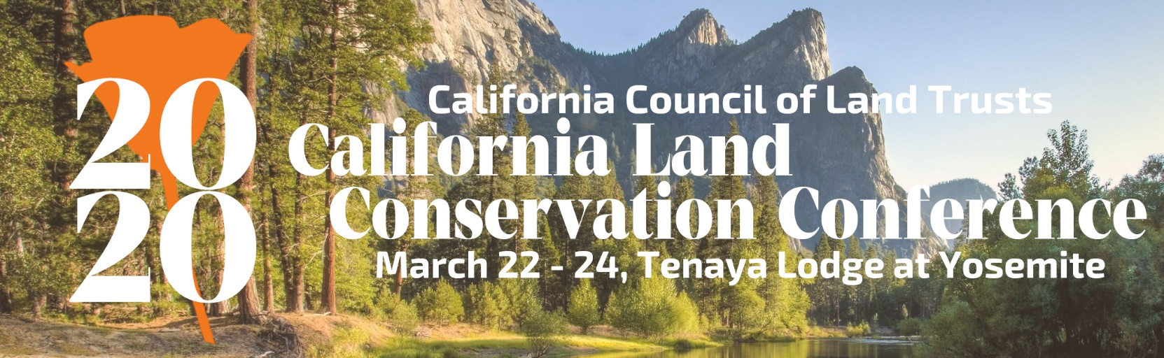

2020 Annual California Land and Water Conservation Conference Sponsorship Opportunities

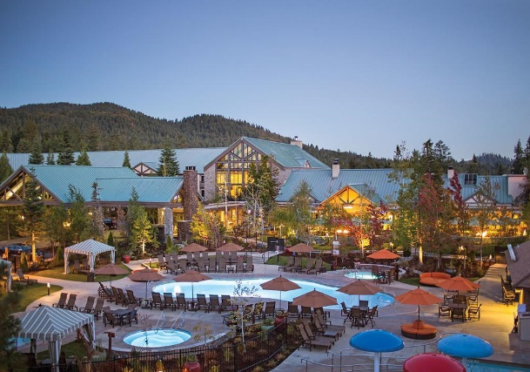
Please mark your calendars to gear up for the 2020 California Land Conservation Conference to be held March 22-24, 2020. This is California's annual premier land and water conservation gathering in the state. This year we are excited that we will be hosting our annual conference at the beautiful Tenaya Lodge at Yosemite. The 2020 California Land and Water Conservation Conference is the on-target occasion for conservation updates on policies, tools, training, resources, emerging issues and expand your contacts. The event attracts hundreds of land and water conservationists from across the state.
Tenaya Lodge at Tahoe
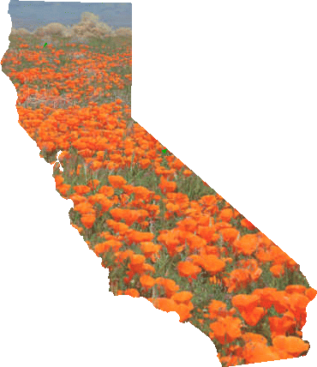
The audience is made up of land trusts board and staff, public agencies, policy makers, experts and other like-minded individuals who support the conservation of land and water resources in California.

Sponsorship of this event is a fantastic way to increase your organization’s visibility with colleagues and other conservation partners. The upcoming conference will introduce some engaging keynote speakers, each year we strive for more interaction with attendees, because your voice adds to the conference success. Our goal is to not only provide education but also generate enthusiasm.

We have also added some exciting new benefits for our sponsors. We offer a unique opportunity to promote your organization among leaders and decision makers of the conservation community in multiple ways. Your investment in this conference also assists in providing cutting-edge information and services to California's land trust members and the state’s conservation community.

CCLT is a nonprofit, statewide body working in the interest of 150 California land trusts
which hold more than five million acres throughout the state.

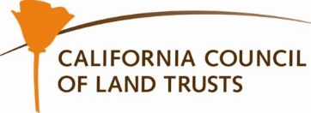

Sponsor Benefits | Benefactor  $10,000 | Guardian  $7,500 + | Steward  $5,000 + | Supporter  $2,500 + | Partner  $1,000 + | Friend  $500 +
Opportunity to present conference welcome during morning plenary session
Complementary Full Conference Registration* | Registration for 4  People | Registration for 3  People | Registration for 2  People | Registration for 1  Person
Complementary Drink Tickets to welcome reception | 5 Tickets | 4 Tickets | 3 Tickets | 2 Tickets | 1 Ticket
Noted as Sponsors in media alerts and social media (Facebook & Instagram)
Logo Recognition on Conference Tote Bag
Organization recognition on all promotional and event materials
Organization/Firm services description in conference packet
Logo recognition on CCLT website for one year
Promotional materials in conference tote bag

*Does NOT include lodging fees.
How will your sponsorship be promoted:
Event promotional materials and signage
CCLT Website: www:calandtrusts.org -- name/logo posted, remaining for 1 year
Constant Contact: Monthly member newsletter and regular conference marketing efforts
(Distribution list of more than 2000)
Facebook: Weekly posts about conference (CCLT has more than 500 likes/followers)
Instagram: Post about Organization (CCLT has more than 270 followers)
Twitter: Weekly posts about conference (CCLT has more than 1,000 followers)

Annual Conference Attendance:
Projected 2020 – 300
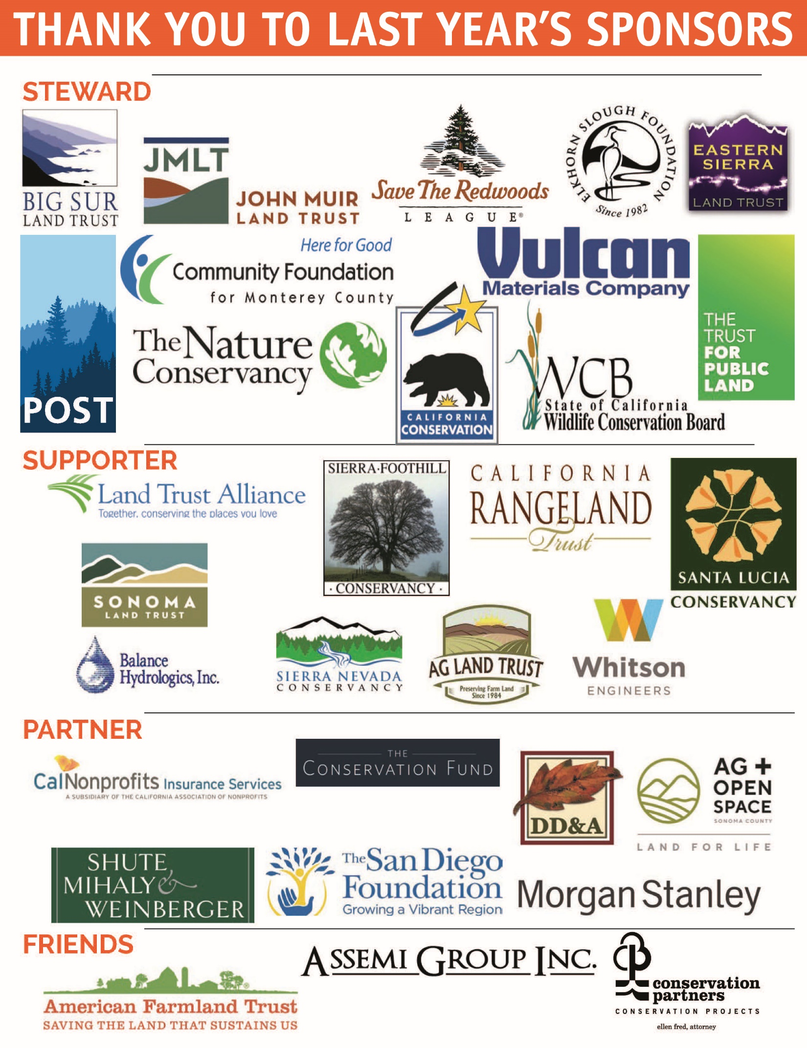
YES! We want to expand our contacts with California's land and water conservation community.

Please sign us up as a sponsor of the 2020 California Land and Water Conservation Conference to ensure your organization's visibility in the conference printed materials.* Complete the form below or contact Kimberly Cox at kimberly@calandtrusts.org or 916-497-0272

Name of Organization: Click or tap here to enter text

Contact Name: Click or tap here to enter text.

Address: Click or tap here to enter text.

Phone: Click or tap here to enter text. Email: Click or tap here to enter text.

Website: Click or tap here to enter text.

*Please notify CCLT prior to our February 14, 2020 printing deadline to ensure recognition on all conference materials.
Yes, we would like to participate as sponsors of the 2020 Land Conservation Conference.

Please check a level of support:

☐Benefactor $10,0000 ☐Guardian $7,500 Add on to any donation:

☐Steward $5,000 ☐Supporter $2,500 ☐ Table Top Display $250

☐Partner $1,000 ☐Friend $500

Payment Options:
☐ Check: Payable to California Council of Land Trusts ☐Please send me an Invoice
☐Online- Click Here or visit www.calandtrusts.org/donate

Please return this completed form to
kimberly@calandtrusts.org
or
California Council of Land Trusts
1029 J Street, Suite 120, Sacramento, CA 95814
Federal ID number: 01—826246
CCLT is a 501(c)3 public benefit corporation in California.

