2018 Annual California Land and Water Conservation Conference Sponsorship Opportunities

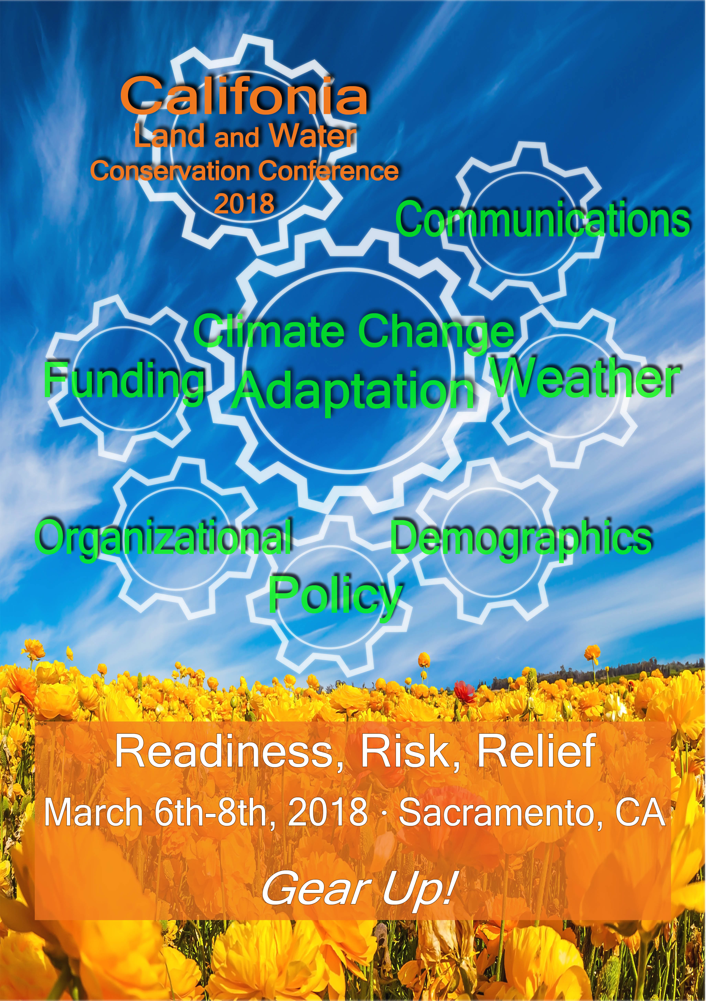
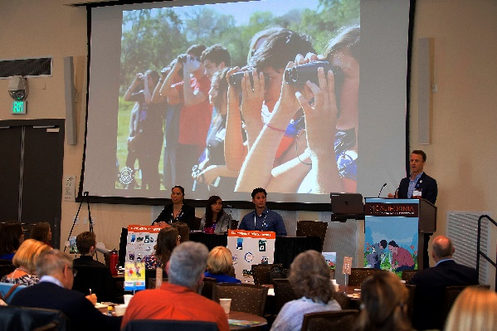
Mark your calendars to gear up for the 2018 California Land Conservation Conference to be held March 6-8, 2018. This is California's annual premier land and water conservation gathering in the state. This year's theme is Climate Change Adaptation: Risk, Readiness, Relief. The "climates" we will be examining include: meteorological, organizational, communication, funding, demographic and policy. The 2018 California Land Conservation Conference is the on-target occasion to highlight your organization and expand your contacts. This annual three-day event attracts hundreds of land and water conservationists from across the state.
The audience is made up of land trusts board and staff, public agencies, policy makers and other like-minded individuals who support the conservation of land and water resources in California.

Sponsorship of this event is a fantastic way to increase your organizations' visibility with colleagues and other conservation partners. The upcoming conference will introduce some new presentation styles, engaging keynote speakers and will feature more interaction with attendees. Our goal is to not only provide education but also generate enthusiasm.

We have also added some exciting new benefits for our sponsors. We welcome you and offer a unique opportunity to promote your organization among leaders and decision makers of the conservation community. Your investment will assist CCLT in providing trending information and services to California's land trust members and those who work in related positions.

CCLT is a nonprofit, statewide body working in the interest of 150 California land trusts
which hold more than five million acres throughout the state.

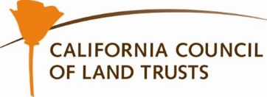

Sponsor Benefits | Benefactor  $10,000 | Guardian  $7,500 + | Steward  $5,000 + | Supporter  $2,500 + | Partner  $1,000 + | Friend  $500 +
Opportunity to present conference welcome during morning plenary session
Single Day Conference Pass | 5 Individual 1-Day Passes | 4 Individual  1-Day Passes | 3 Individual  1-Day Passes | 2 Individual  1-Day Passes | 1 Individual  1-Day Passes
Complementary Tickets to Welcome Dinner | 5 Tickets | 4 Tickets | 3 Tickets | 2 Tickets | 1 Ticket
Invitation to major donor luncheon at conference | 5 Tickets | 4 Tickets | 3 Tickets | 2 Tickets | 1 Ticket
Logo recognition on all promotional and event materials
Noted as Sponsors in media alerts and social media (Facebook & Instagram)
Logo Recognition on Conference Tote Bag
Name recognition on all promotional and event materials
Organization/Firm services description in conference packet
Logo recognition on CCLT website for one year
Member pricing for all conference events and activities
Promotional materials in conference tote bag

How will your sponsorship be promoted:
Event promotional materials and signage
CCLT Website: www:calandtrusts.org -- name/logo posted and remains for 1 year
Constant Contact: Monthly member newsletter and regular conference marketing efforts
(Distribution list of more than 2000)
Facebook: Weekly posts about conference (CCLT has more than 460 Likes)
Instagram: Post about Organization (CCLT has rapidly growing followers)
Twitter: Weekly posts about conference (CCLT has more than 1,000 followers)

Annual Conference Attendance:
Projected 2018 – 550

YES! We want to expand our contacts with California's land and water conservation community.

Please sign us up as a sponsor of the 2018 California Land Conservation Conference to ensure our organization's visibility in the conference printed materials.* Complete the form below or contact Kimberly Cox at kimberly@calandtrusts.org or 916-497-0272

Name of Organization: Click or tap here to enter text

Contact Name: Click or tap here to enter text.

Address: Click or tap here to enter text.

Phone: Click or tap here to enter text. Email: Click or tap here to enter text.

Website: Click or tap here to enter text.

*Please notify CCLT prior to our January 11,2018 printing deadline to ensure recognition on all conference materials.
Yes, we would like to participate as sponsors of the 2018 Land Conservation Conference.

Please check a level of support:

☐Benefactor $10,0000 ☐Guardian $7,500 Add on to any donation:

☐Steward $5,000 ☐Supporter $2,500 ☐ Table Top Display $250

☐Partner $1,000 ☐Friend $500

Payment Options:
☐ Check: Payable to California Council of Land Trusts ☐Please send me an Invoice
☐Online- Click Here or visit www.calandtrusts.org/donate

Please return this completed form to
kimberly@calandtrusts.org
or
California Council of Land Trusts
1029 J Street, Suite 120, Sacramento, CA 95814
Federal ID number: 01—826246
CCLT is a 501(c)3 public benefit corporation in California.

